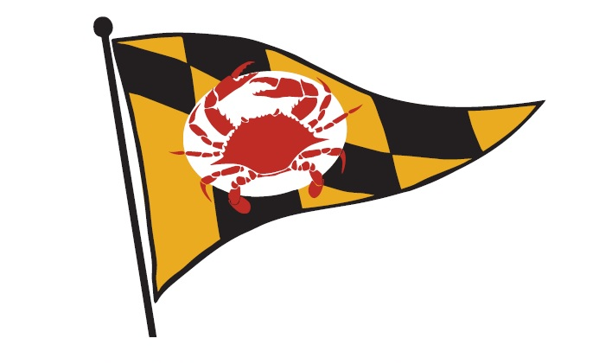
BALTIMORE COUNTY SAILING CENTER

Future Leaders Camp Application
Email application to programs@bcsailing.org
Name:______________________________________________________________________
What Programs have you attended at BCSC? ____________________________________________________________________________
Do you have a Maryland State Boaters License? Yes/ No
Do you plan to be a Sailing Instructor in the future? Yes/ No
Do you have any previous Job Experience? If so explain. Yes/No
________________________________________________________________________________________________________________________________________________________
What does the Baltimore County Sailing Center mean to you?
________________________________________________________________________________________________________________________________________________________________________________________________________________________________________________________________________________________________________________________________________________________________________________________________________________________________________________________________________

